Kingdom of Saudi Arabia  Ministry of Education  Northern Border University  Faculty of Computing and Information Technology | الـمـمـلـكـة الـعـربـيـة الـسـعـوديـة  وزارة الـتـعـلـيـم  جـامـعـة الـحـدود الـشـمـالـيـة  كـلـيـة الـحـاسـبـات وتـقـنـيـة الـمـعـلـومـات
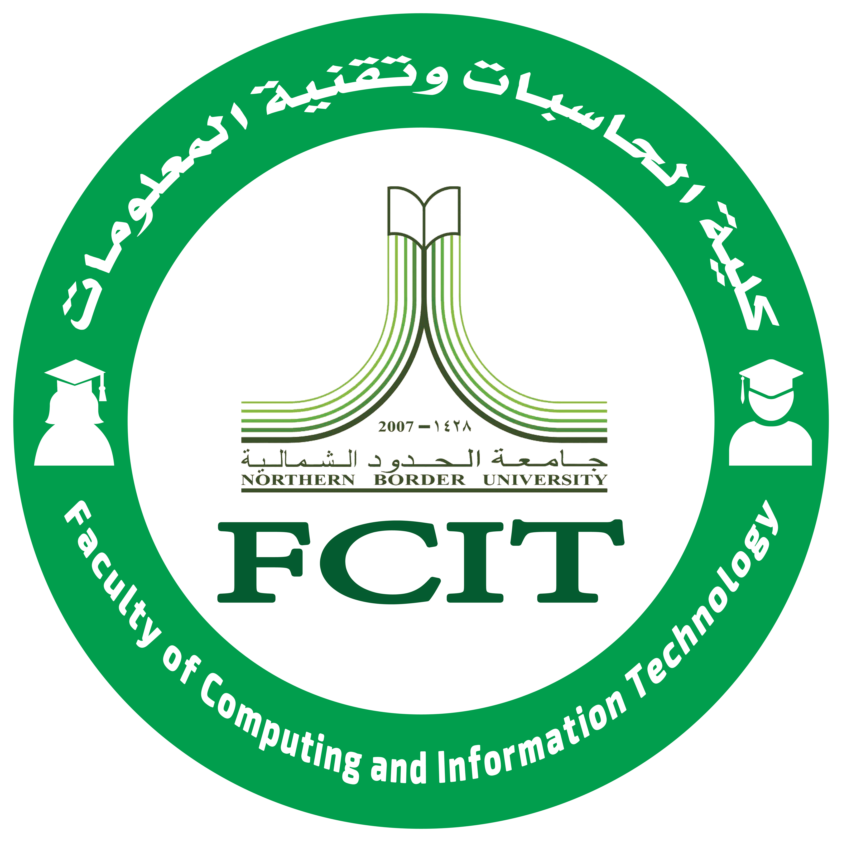

Timetable and Office Hours

Teacher Name: XXXXXXXXXXXXXXXXXXX

SPRING 2019

Department: XXXXXXXX Ext: XXXX Email: xxxxxxxxxxxxxx@nbu.edu.sa
17 – 17:50 | 16 – 16:50 | 15 – 15:50 | 14 – 14:50 | 13 – 13:50 | 12 – 12:50 | 11 – 11:50 | 10 – 10:50 | 9 – 9:50 | 8 – 8:50
 |  |  | Boys – Internet App.  CPIT405 | Boys – Internet App.  CPIT405 | Office Hour | Office Hour | Girls – Internet App.  CPISXXX & CPITXXX |  |  | Sunday
 |  |  | L202 | L202 |  |  | C112
 |  |  |  |  |  |  |  |  |  | Monday
 |  |  |  |  |  | Student Activities |  |  |  | Tuesday
 |  |  |  |  |  |  |  |  |  | Wednesday
 |  |  |  |  |  |  |  |  |  | Thursday

